UF Emergency Department Split-Flow Operating Model

Executive Summary and Reference Overview

Executive Summary
UF Emergency Department will implement a split-flow operating model to improve access, reduce LWBS, and protect main ED beds for high-acuity and bed-dependent care. Split flow establishes early attending-led clinical decision-making at the front door and creates parallel care pathways (discharge from intake, vertical (Super Track), and main ED after intake) so care begins immediately and capacity is used appropriately. The model is designed for the peak demand window (08:00–01:00) and is managed through clear flow governance and an outcomes-driven dashboard with safety balancing measures.
Problem and Opportunity | What Will Change (Split Flow)
- Long door-to-clinician times during surges; waiting room becomes the buffer.  - High LWBS driven by delayed clinical contact and perceived inaccessibility.  - Bed dilution: non–bed-dependent care occupying rooms needed for higher acuity.  - Variation at the front end (triage depth, early ordering, reassessment cadence) increases LOS variability. | - Front-end care initiation: rapid screening plus attending-physician intake evaluation to start the MSE and initiate early orders.  - Streaming: discharge-from-intake, Super Track (vertical), or main ED after intake; red/bypass patients directly bedded.  - Vertical care as core throughput: non bed pathway with explicit inclusion criteria and pull-back triggers.  - Flow governance + standard work: clear decision rights, EHR-enabled lanes, standardized order sets, and a dashboard with safety guardrails.

Expected Outcomes (Targets to be Finalized with UF Baseline)
Domain | Metric | Initial | Steady-State
Access | Door-to-Clinician (median / P90) | ≤ 15 min / ≤ 45 min | ≤ 10 min / ≤ 30 min
Leakage | LWBS (leave before MSE completion) | ≤ 3.0% | ≤ 1.0%
Throughput | ED LOS – Discharged (median / P90) | ≤ 4.5 hr / ≤ 7.0 hr | ≤ 4.0 hr / ≤ 6.5 hr
System | Ambulance Offload (median / P90) | ≤ 20 min / ≤ 45 min | ≤ 15 min / ≤ 30 min

Model at a Glance
Split flow converts waiting time into care time by initiating the Medical Screening Exam and key diagnostics early, while protecting bed capacity for patients who truly require bed-based care.

Figure 1. Attending-Physician Intake Model and Patient Flow (benchmark distribution; UF will validate locally).
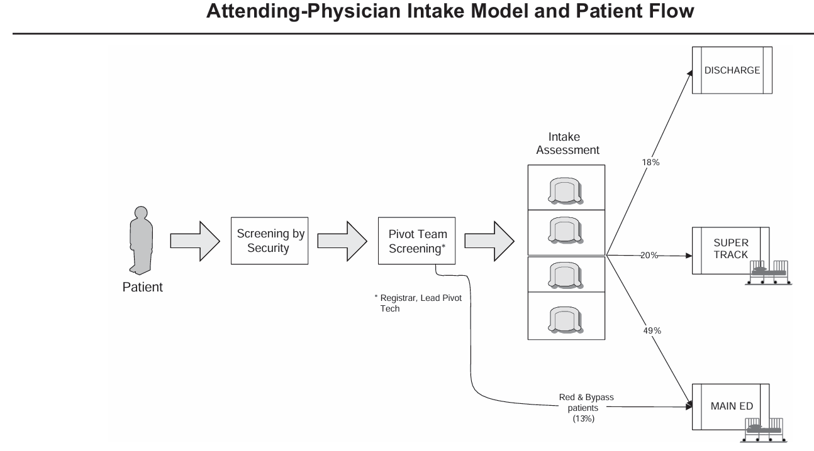

Care Pathways (Lane Definitions)
Lane | Who | Operational Intent / Notes
Red / Bypass → Main ED | Time-sensitive or unsafe-to-intake patients | Immediate bedding; activate condition pathways; lowest threshold to bed.
Discharge from Intake | Appropriate low-risk presentations after intake MSE | Treat-and-release with standardized discharge pathways and return precautions.
Super Track (Vertical) | ESI 4–5 + selected ESI 3 appropriate for non bed based care | Dedicated staffing; reassessment cadence; explicit pull-back triggers.
Main ED after Intake | Bed-dependent/complex ESI 3s and up, and others needing bed-based workup | Orders initiated in intake; standardized handoff to main team; bed protection enforced.

Benefits (Why This Is Good for Patients, the Department, and the Hospital)
Patients | Department | Hospital
- Earlier clinician contact; reduced unsafe waiting  - More predictable journey and communication  - Lower LWBS and fewer interruptions | - Reduced front-end variation; reliable standard work  - Protected high-acuity bed capacity  - Improved teaching environment and staff experience | - Improved ED access and community reputation  - Reduced ambulance offload delays and crowding spillover  - Reduced demand leakage; stronger downstream capture

Resource Inventory
The inventory below enumerates minimum personnel, space, and enabling resources required to operate split flow during 08:00–01:00. This is designed to translate directly into budget line items (coverage hours, FTE equivalents, equipment and IT build).

Personnel
Functional Area | Role | Positions on Duty
Front-End Intake (Pivot + RME) | Intake Attending (Provider-in-Triage) | 1.0
Front-End Intake (Pivot + RME) | Scribe (Intake) | 1.0
Front-End Intake (Pivot + RME) | Pivot / Lead ED Tech | 1.0
Front-End Intake (Pivot + RME) | Movement ED Tech | 1.0
Front-End Intake (Pivot + RME) | Quick Registration Registrar | 1.0
Front-End Intake (Pivot + RME) | Intake Support RN | 0.5–1.0
Vertical Care (Super Track) | Super Track Clinician (APP-led) | 1.5 (staggered staffing model)
Vertical Care (Super Track) | Super Track RN | 1.0
Vertical Care (Super Track) | Super Track ED Tech | 0.5–1.0
Flow Governance | Charge RN / Flow RN (designated) | 1.0

Space and Physical Plant (Minimum Viable Build)
- Front-end Pivot + Quick Registration zone adjacent to entrance with direct waiting room visibility.
- Intake evaluation: 2–4 chair/exam-bay positions with privacy screens/curtains and dedicated workstations.
- Super Track: 12–18 chairs/recliners (starting point) plus access to 3-6 privacy-capable rooms with beds.
- Clear pull-back route and criteria from intake or Super Track to main ED beds; signage and single-direction flow where feasible.

IT, Equipment, and Operational Dependencies
- EHR: quick registration enabling orders, lane-based tracking board, intake/vertical templates, standardized order sets.
- Front-end devices: vitals + ECG capability dedicated to intake; sufficient devices to avoid bottlenecks.
- Analytics: automated dashboard for door-to-clinician, LWBS, LOS, lane volumes, and balancing measures.
- Operational partners: defined lab/radiology turnaround expectations and escalation; transport/EVS support during peak.

Governance, Dashboard, and Implementation Roadmap

Governance Cadence
- Shift-level flow leadership with clear decision rights (Charge/Flow RN, Intake Attending, Super Track Lead).
- Start-of-window huddle and board rounds every 60–120 minutes during peak.
- Daily 15-minute review of north-star metrics with action log and owners.
- Weekly operations review (trend + root cause + standard-work updates).
- Monthly executive steering review focused on access, boarding/output constraints, and resource alignment.

Safety Balancing Measures
Measure | Definition | Guardrail
72-hr returns | % of discharges returning within 72 hours (stratify by pathway). | No increase vs baseline; investigate >10% relative rise.
72-hr return admissions | % returning and admitted within 72 hours. | No increase vs baseline; case review for upward trend.
Time-critical pathways | Door-to-ECG (ACS), stroke CT timing, time-to-antibiotics (sepsis/shock). | Maintain/improve vs baseline; meet service-line targets.
Vertical escalation with harm | Escalation from vertical with adverse outcome. | Zero tolerance; immediate review.

Implementation Roadmap (High Level)
Phase | Duration | Deliverables | Go/No-Go
Design | Wks 1–4 | Baseline KPIs; lane criteria; space map; EHR build plan; staffing grid. | Definitions locked; space identified.
Build | Wks 5–8 | Front-end setup; order sets/templates; training/simulation; dashboard prototype. | Staff trained; EHR tested.
Pilot | Wks 9–12 | Operate 08:00–01:00; daily huddles; rapid-cycle improvement. | KPI trends improve; no safety signal.
Scale | Mo 4–6 | Refine staffing/space; enhance vertical capacity; hardwire governance. | Sustained performance; budget alignment.

Decision and Next Steps
- Approve split-flow lane architecture and design standards as the UF ED operational reference model.
- Authorize detailed staffing and space planning to determine incremental vs redeployed resources for 08:00–01:00.
- Prioritize EHR build and analytics automation required for lane visibility and the governance dashboard.
- Establish executive steering for hospital throughput constraints (boarding, imaging/lab, transport) that directly impact ED access.

